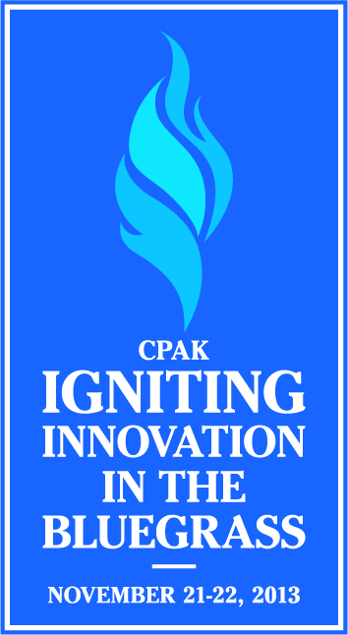  CPAK Dine Discuss & Discover Brown Bag  Date: Tuesday, October 22 at 1:00pm-1:50pm EST  Location: Campus Center, Room 201  Event Host: Jacob Raderer jacob.raderer@centre.edu  Find out more about our upcoming Annual Conference, Professional Development opportunities & open EC Positions!  Find us at www.cpak.org, @KYCPAK & #CPAKchat  Annual Meeting: November 21-22nd in Louisville  Careers in Student Affairs: November 23rd @ Centre |  | CPAK Dine Discuss & Discover Brown Bag  Date: at  Location:  Event Host: Jill Petrey  Find out more about our upcoming Annual Conference, Professional Development opportunities & open EC Positions!  Find us at www.cpak.org, @KYCPAK & #CPAKchat  Annual Meeting: November 21-22nd in Louisville  Careers in Student Affairs: November 23rd @ Centre
CPAK Dine Discuss & Discover Brown Bag  Date: Wednesday, October 23 at 12:00pm-12:50pm EST  Location: Porter Conference Room, 3rd floor of Cralle Student Center  Event Host: Mike Brown michael_brown@georgetowncollege.edu  Find out more about our upcoming Annual Conference, Professional Development opportunities & open EC Positions!  Find us at www.cpak.org, @KYCPAK & #CPAKchat  Annual Meeting: November 21-22nd in Louisville  Careers in Student Affairs: November 23rd @ Centre |  | CPAK Dine Discuss & Discover Brown Bag  Date: Monday, October 21 at 12:00pm-12:50pm EST  Location: Jefferson Education Center 2nd Floor Conference Room  Event Host: Taylor McGovern U'Sellis taylor.usellis@kctcs.edu  Find out more about our upcoming Annual Conference, Professional Development opportunities & open EC Positions!  Find us at www.cpak.org, @KYCPAK & #CPAKchat  Annual Meeting: November 21-22nd in Louisville  Careers in Student Affairs: November 23rd @ Centre
CPAK Dine Discuss & Discover Brown Bag  Date: Monday, October 21 at 12:00pm-12:50pm EST  Location: Student Center Room 359  Event Host: Faith N. Cracraft faith.cracraft@uky.edu  Find out more about our upcoming Annual Conference, Professional Development opportunities & open EC Positions!  Find us at www.cpak.org, @KYCPAK & #CPAKchat  Annual Meeting: November 21-22nd in Louisville  Careers in Student Affairs: November 23rd @ Centre |  | CPAK Dine Discuss & Discover Brown Bag  Date: Monday, October 21 at 12:00pm-12:50pm EST  Location: Miller Hall First Year Resource Center  Event Host: Ashleigh Taylor a0tayl06@louisville.edu  Find out more about our upcoming Annual Conference, Professional Development opportunities & open EC Positions!  Find us at www.cpak.org, @KYCPAK & #CPAKchat  Annual Meeting: November 21-22nd in Louisville  Careers in Student Affairs: November 23rd @ Centre
CPAK Dine Discuss & Discover Brown Bag
Date: Tuesday, October 22 at 12:00pm-12:50pm EST
Location: Wetherby - Large Conference Room
Event Host: Lindsey Gilmore and Aaron Hughey lindsey.gilmore@wku.edu
Find out more about our upcoming Annual Conference, Professional Development opportunities & open EC Positions!
Find us at www.cpak.org, @KYCPAK & #CPAKchat
Annual Meeting: November 21-22nd in Louisville
Careers in Student Affairs: November 23rd @ Centre

